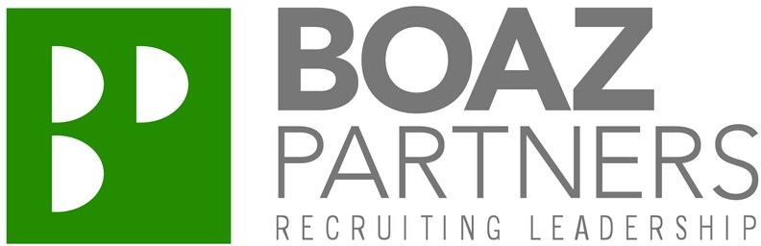

Completely Virtual
I N T E R V I E W T O O F F E R

R O L E

Global Quality Leader for a world- leading animal health company: diagnostics and bio-devices division

T O O L S

Boaz Partners utilized video conferencing technology, including international toll- free dialing capabilities.

Can set up interview panels with multiple locations.

"Virtual interviewing from cradle to grave (phone screen to accepting the offer) is a unique experience that provided me the opportunity to fully evaluate the organization culture and its appetite for upcoming technology. Given current requirements and demands for live connections, and geographic challenges, many organizations are opting to cost effective methods to provide an equivalent level of connection. Personally, I’ve enjoyed the virtual interviewing process and looking forward to deploying similar methods of interviewing across my platform."
- Candidate

Let us help you navigate the changing times. 470.440.2035
www.boazpartners.com

C H A L L E N G E

Navigate the evolving need to socially distance and utilize technology to establish a connection and comfort level in candidate technical competency and cultural fit.

Multiple levels and individuals required to approve candidate hire prior to a formal offer being extended.

Coordinate interviews across multiple countries and time zones.

P R O C E S S

Boaz Partners scheduled 8 global phone and video interviews across Belgium, Ireland, California, and Michigan.

Candidate debriefs at every stage with client engagement moving candidate forward in interviewing process.

Client allowed candidate to do deep questioning regarding facilities and corporate environment

R E S U L T S

An offer was extended and accepted without having an on-site presence in any location.

Candidate is relocating cross-country.

